**1.c** Comparison of two histogram for values of n = 10, 100, 1000 and p = 0.1, 0.5 and

0.6

1 ) n=10, p=0.1,no of trails=1000

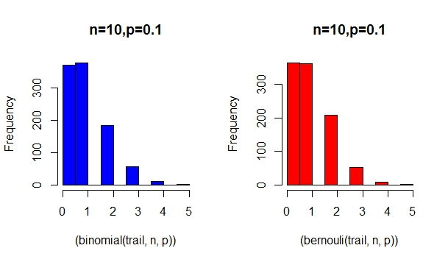

2) n=10,p=0.5,no of trails=1000

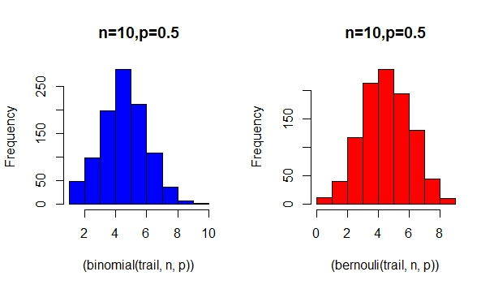

3) n=10,p=0.6,no of trails=1000

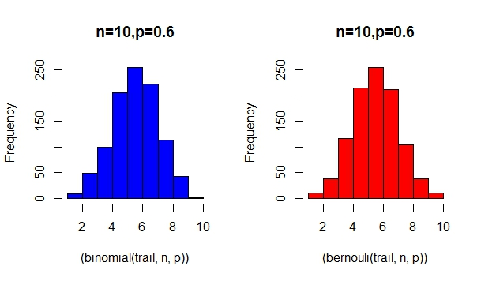

4) n=100,p=0.1,no of trails=1000

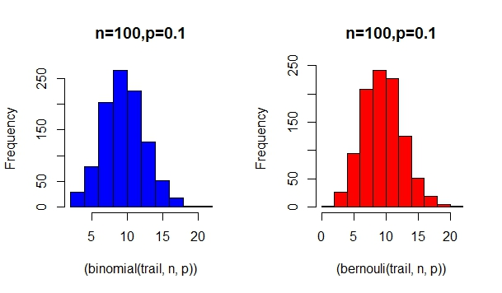

5) n=100,p=0.5,no of trails=1000

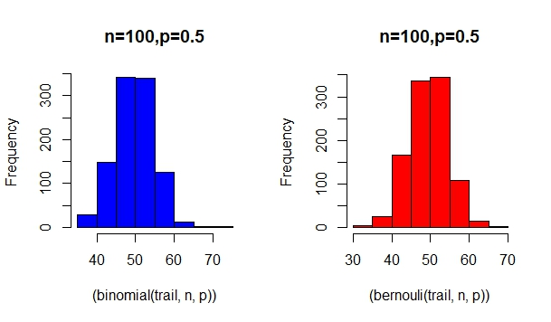

6) n=100,p=0.6,no of trails=1000

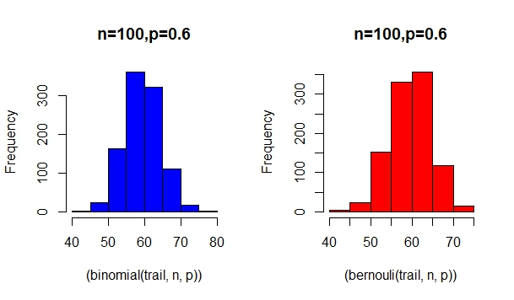

7) n=1000,p=0.1,no of trails=1000

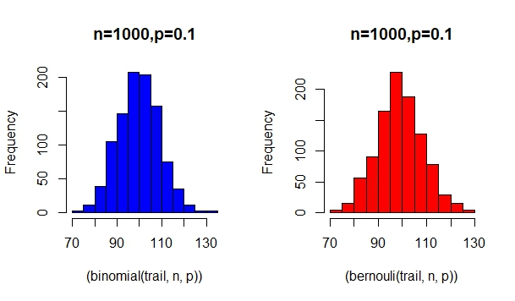

8) n=1000,p=0.5,no of trails=1000

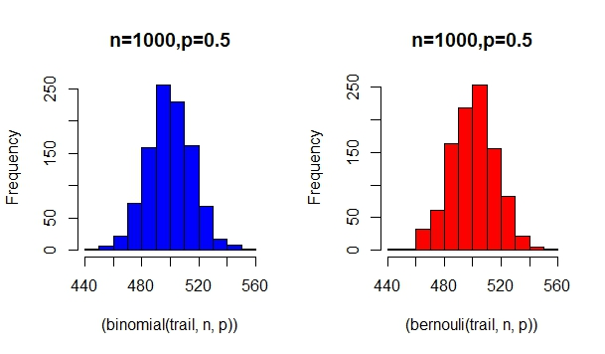

9) n=1000,p=0.6,no of trails=1000

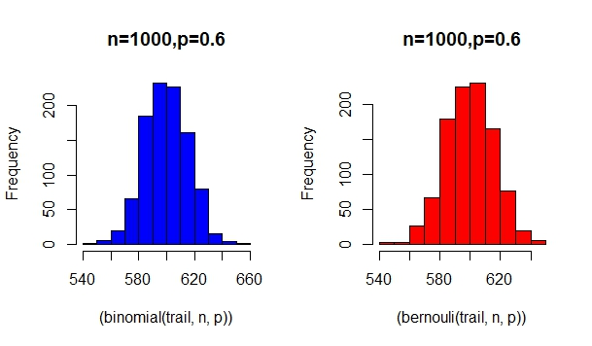

1. **D** We can approximate the binomial distribution by Bernoulli distribution with parameter 1

Question 2

(2) for N = 1000

the fraction of products that were thrown out as defective=0.01830782

the fraction of products that either had wrong paint or did not have radius between

9.6cm and 10.4cm=0.01742258

the fraction of products that had the right paint and radius between 9.6cm and 10.4cm,

but were still classi_ed as defective=0.00170658

the fraction of products that had either wrong paint or wrong radius but were not thrown

out=

for N=10000

the fraction of products that were thrown out as defective=0.01708637

the fraction of products that either had wrong paint or did not have radius between

9.6cm and 10.4cm=0.01612875

the fraction of products that had the right paint and radius between 9.6cm and 10.4cm,

but were still classi_ed as defective=0.001714049

the fraction of products that had either wrong paint or wrong radius but were not thrown

out=

(3)if checked for all products

for N = 1000

the fraction of products that were thrown out as defective=

the fraction of products that either had wrong paint or did not have radius between

9.6cm and 10.4cm=

the fraction of products that had the right paint and radius between 9.6cm and 10.4cm,

but were still classi_ed as defective=

the fraction of products that had either wrong paint or wrong radius but were not thrown

out=

for N=10000

the fraction of products that were thrown out as defective=

the fraction of products that either had wrong paint or did not have radius between

9.6cm and 10.4cm=

the fraction of products that had the right paint and radius between 9.6cm and 10.4cm,

but were still classi_ed as defective=

the fraction of products that had either wrong paint or wrong radius but were not thrown

out=

(4)we can consider those products which were correct but were thrown out.